# Jeffery. Dirden

ITAI 1370

# Professor Esmalifalak

# November 22, 2024

A10

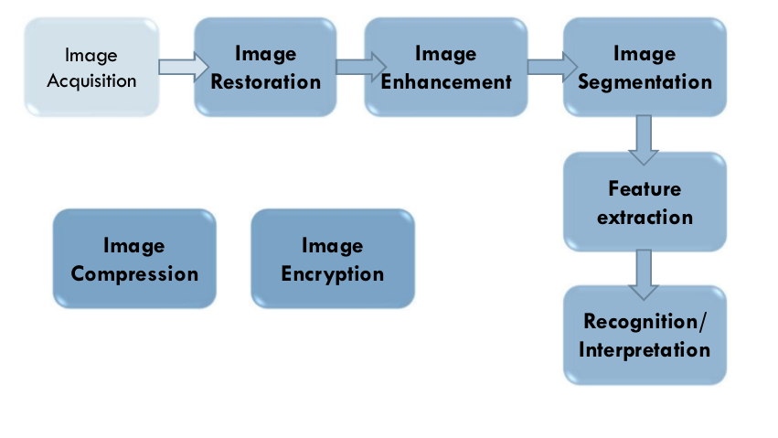

After doing some research and going over multiple diagrams that show the image understanding process I decided to use this common chart because it covers the information with simplicity, and efficiency. The 1st step is image acquisition where the image is captured or obtained. This could be from a camera, scanner, or different device for example. The 2nd step is image restoration which improves the quality of the captured image. 3rd step is image enhancement which highlights the important features of the image. 4th step is image segmentation which divides the image into important regions or segments. 5th step is feature extraction which identifies unique attributes, patterns, textures, etc of a image. 6th step is reading the features to categorize and understand what the image actually represents. There are additional steps labeled as parallel processes, which consists of image compression where the file size is reduced yet maintaining important information. Image encryption which is also another step secures the image data through encryption to ensure that the data is protected.